PF Lab Task 10

Muhammad Ehsan Ul Haque (24K-0798)

Q1)

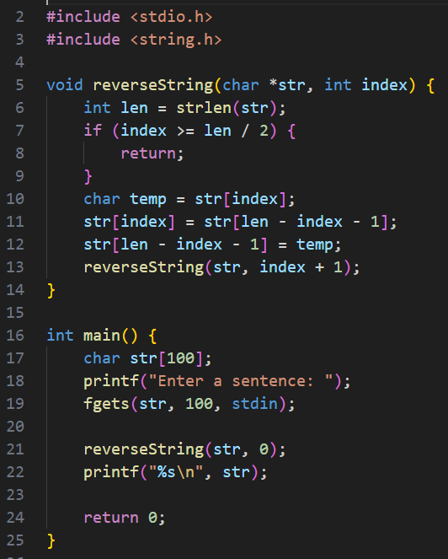

Q3) 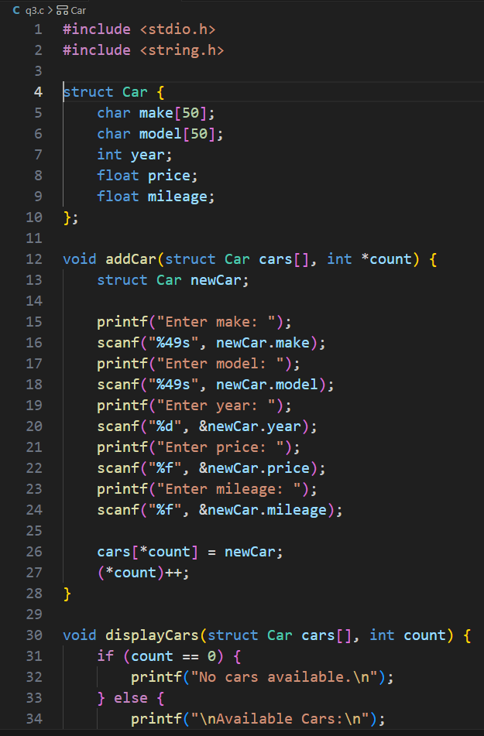

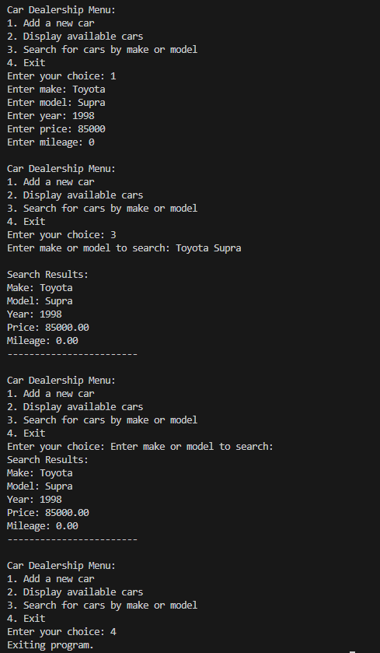

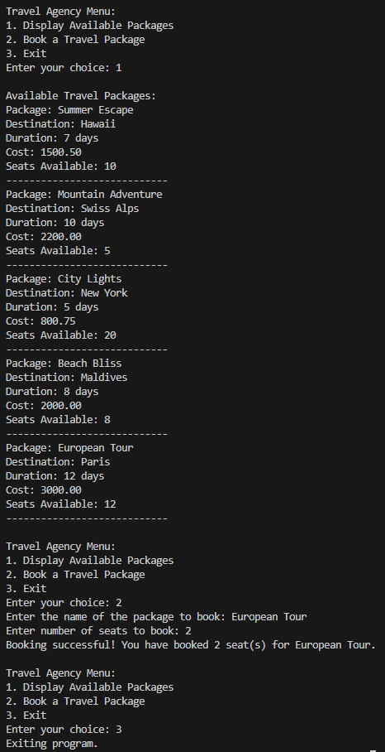

Q8) 

